🗺️ End-User's Guide to Using the Report Generator
(⌚ Est time needed: 5 to 10 minutes)

1️⃣ Download the following file into your device.

- ⚙️Report Generator
- 🖼️Support file 1: Placeholder Header Image
- 📈Support file 2: xlsx template file (based on the assigned dataset)

2️⃣Save all files in one folder of your preference within your device. For best result, ensure that there are no other files within that folder.

3️⃣Run the report_gen_rough_prototype.exe file.
📝If the prompt below appeared, click on “More info”
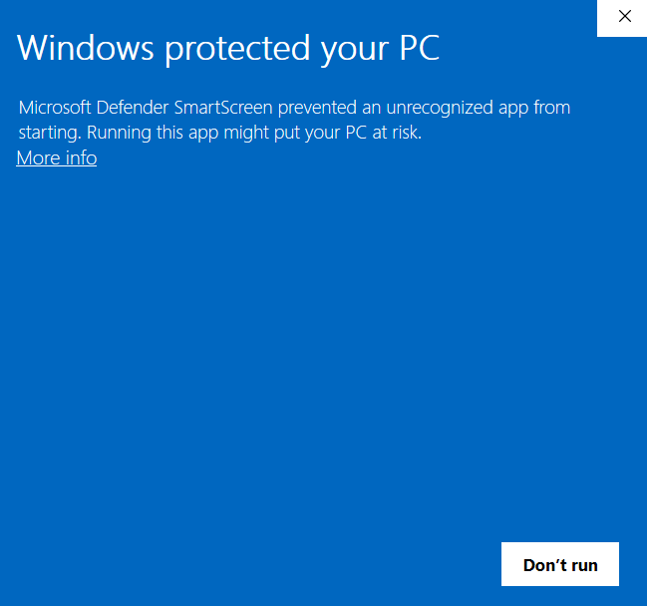
Then, click “Run anyway”.
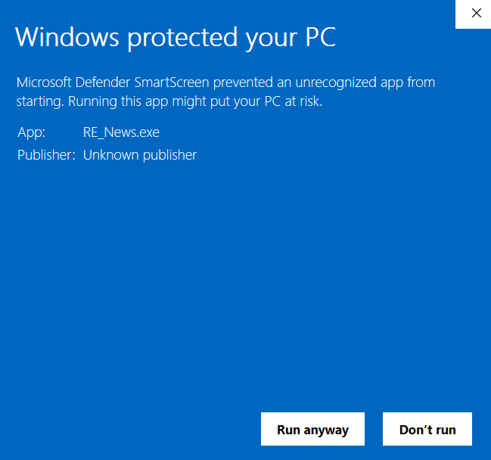
4️⃣This will then appear on your screen.



5️⃣Give the application around 10 to 30 seconds to load. This will then appear.

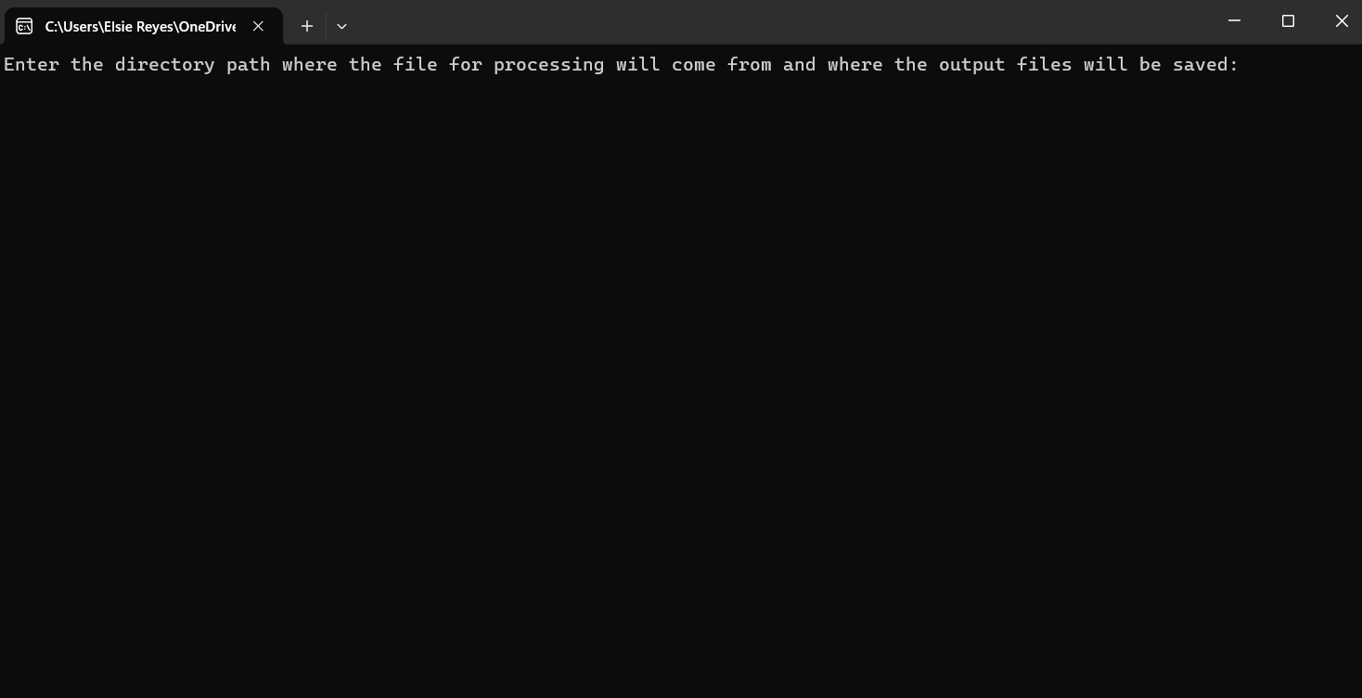

6️⃣Go to a folder where you desire to save the files that will be generated from running the exe file. Ideally, this is the same folder where you saved 🖼️Support file 1: Placeholder Header Image, 📈Support file 2: xlsx template file (based on the assigned dataset), and ⚙️Report Generator. Right-click on the address path name, as shown in the image below. Click “Copy Address”.

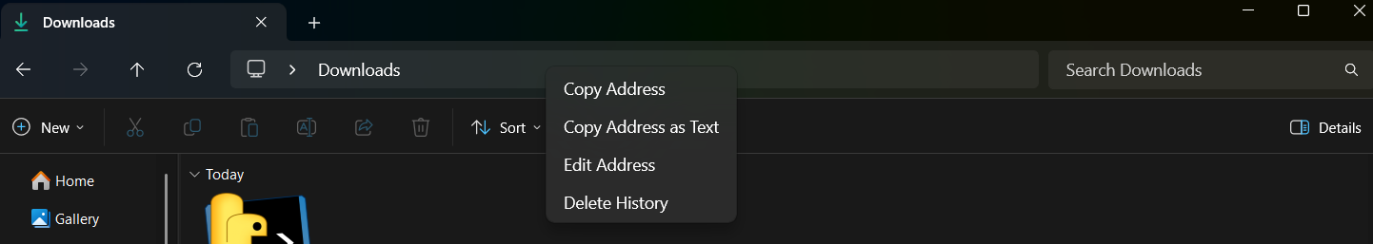

7️⃣Go back to the exe file and press Ctrl + V, and then press Enter afterwards.

8️⃣Give it roughly one to three minutes to generate all the files. Once done, the files will be found in the folder you specified (file path you pasted onto the exe file before it ran).

📝Note: After downloading the files into your local drive, no need to repeat the process again. Just start with Step 3 whenever you need to generate reports.

